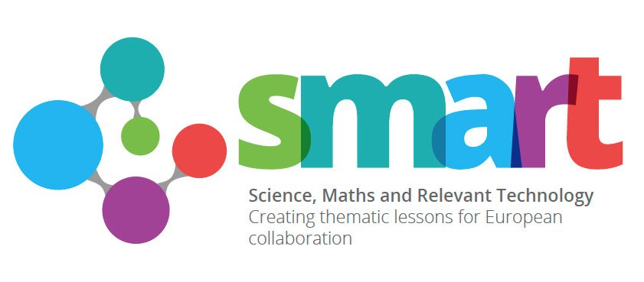

Smart Week April 11th - April 15th 2016

EVALUATION –D HSB

Ross Spearing attended the meeting at the lead UK school, Tavistock College, to discuss the project so far and future strategies and arrangements.

DHSB hosted the visiting staff and students on Wednesday 13th of April.

WWW
- Well planned and clear instructions from the lead UK school about the general itinerary and the essential meetings to be attended.
- Good turnout and participation from the project schools.
- A visit to the Plymouth STEM centre located at Plymouth City College. This is a new facility which offers various demonstrations and experiments for students to see the applications of STEM and various cutting-edge developments. The visiting staff and students attended this alongside DHSB students.
- A joint student challenge at DHSB for the afternoon which encouraged lots of communication and interaction whilst incorporating various aspects of STEM.

EBI
- DHSB students to attend the activities at Tavistock College for greater multicultural and lingual exposure.
- Tavistock College students to attend the activities at DHSB.
- Increased communication for afterschool activities that DHSB students could attend (We were not aware until the day that the visiting students went bowling after the visit at our school).

