Monday

On monday morning, we went to Tavistock College with the bus, we met all the students and the teachers. Some stayed at the school for a meeting and others went on the bus with Keith, our nice driver, to visit Tavistock, Plymouth and the area around. That was really beautiful, we saw free animals like sheeps and poneys.

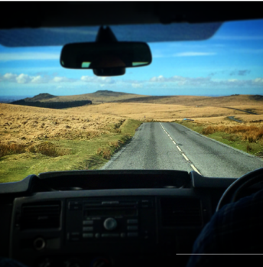

We went to a little village called Palpero, we had a wonderful weather. That was fantastic , we ate pasties and scones on the top of the hill. We took a tea in a typical pub, we loved it.

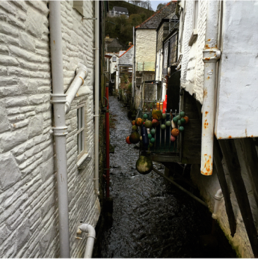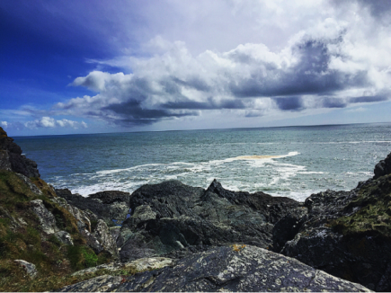
Palpero

We went back to tavistock College and we visited the sport centre with the pool.
We met the teachers and staff and we went back to our hotels.

That was a lovelly first smart week day, when we had the opportunity to meet each other : French, Swedes, Lithuanian & English teachers & students.

Tuesday

On tuesday morning we went to Tavistock College, we met the students that made boats : different teams from different ages. Then we went to the cannal to test their boats and they made modifications when it didn’t work. It was really interesting to see how we could use sciences in other ways that in regular school lessons. We were impressed by the boats because they were so nice and made in a really short time. And we also were impressed by the team’s motivation to analyse the situation and find solutions to their problems in order to improve their boat.
In the afternoon we tried tree surfing and we had really good fun. We were located in an area of outstanding natural beauty. It was a chance to run wild and have an adventure together.

Team n°1:

Harry 13, Tom 13 and Oliver 14, helped by Mr.Moore built their boat called “Sixteen and Pregnant”. It took them about a month to make it. They loved to make it, they worked on it almost every day at lunch time. The hardest part for them was to make the two floatteurs look the same for the float.

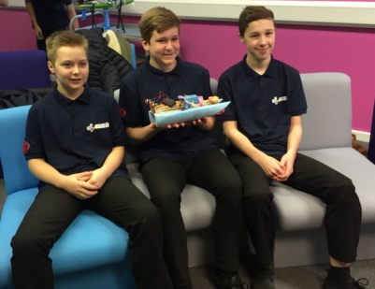

Team n°2:

Ben, Chris and Franckie, 13 and 14 made their boat called “Hims Tazoo” in two weeks. They worked every day mostly at lunch break with the help of Mr. Jackson. They built it with plastic from an old boat. For them, the hardest part of their work was to make the connection with the battery and to build it.
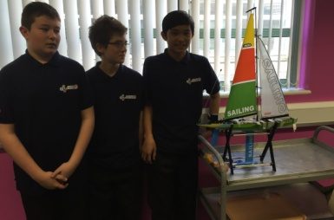

Team n°3:

Sophie, Emily and Lauren, aged of 14 years old took two weeks to make their boat. They worked during school and after school. The hardest part for them was to start the boat.

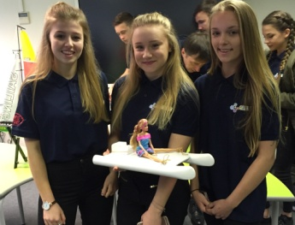

Team n°4:

Darcy, Rhian and Katy, helped by Mr J.Wates have created a boat called “Retro Navem” with plastic and plastic bottles. They made the boat in 10 days, they struggled to design the boat and to put electricity in it.

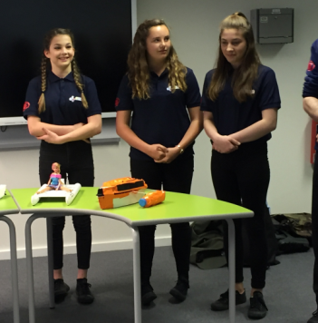

Team n°5:

Georgia, Shown, Scott and Joe 16 and 17 really enjoyed making their boat called “Big Bertha”, they didn’t take much time to do it but it was stressfull for them. They didn’t have a lot of time to do it because they were really busy with their exams and homeworks.

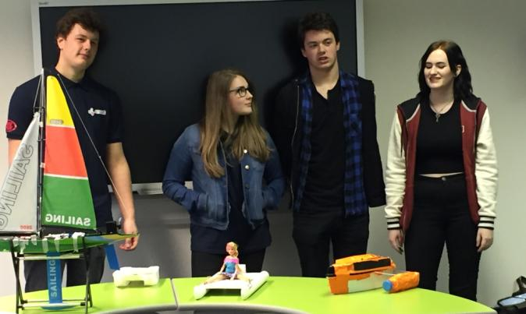

Team n°6:

Tom, Jack,Tom and Adam have 16 and 17 yers old. They also took two weeks to do their boat called “Bob the Boat”, they struggled to put the motor in it. It was stressfull for them too but a lot of fun at the same time.

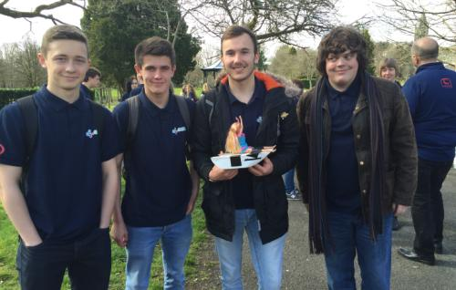

Wednesday

On wednesday morning we went to Devonport High Scool and to the STEM Center, we made some fun activities live stop motion videos on our theme of energy.

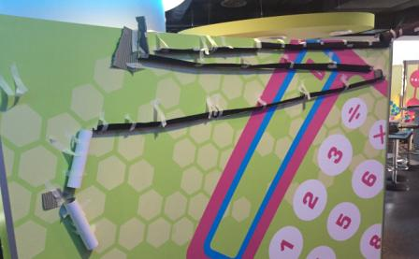

We ate at the school refectory and in the afternoon we went on physics lessons for two hours where we made experimentations.

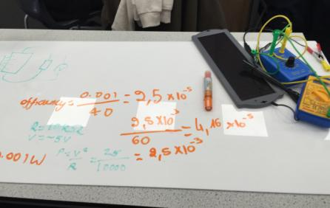

After that, teachers went on a project meeting, then went to a chinese restaurant, while students have been doing a bowling and eating pizzas. A really nice & interesting day again.

Thursday

Competition day !

Back to the cannal, for the final test !

On thursday morning, Tristan, our lovely host, did a speech to intoduce the competition then we went to the cannal where the students had time to test their boats again and to make modifications and then they had the competition. It was fun!

Next we had lunch and in the afternoon the swedish team, who was the jury, told everyone who the winners was.

And the winner is…. “Sixteen and Pregnant” with 20 point, congratulation to Tom, Oliver and Harry for their work!

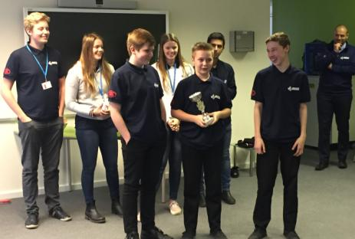

So they go to Sweden next year. They were really happy to win but everyone else was disappointed but happy for the experience and the things the competition brought to them!
Well done to everyone!

After that we all met at the Rock Fish in Plymouth to eat all together and we had a really good last night.
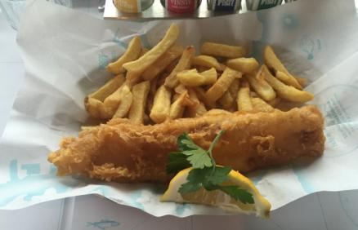

The Swedich team:

Nalli, Samuel, Amanda and Miranda, helped by their teachers Emma, Louise and Danny had to judge the competition and say who’s the winner. The three rules were: to be the fastest, to use the less energy and to go the further. They had to do that and carry a barbie doll on the boat.
The team mesured the energy taken by the boat, the speed and the weight.

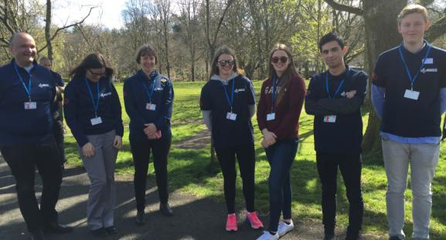

The lithuanian team:

Andrius and Alius with their teachers had to film and make a little movie of the week with interviews and description of the week.

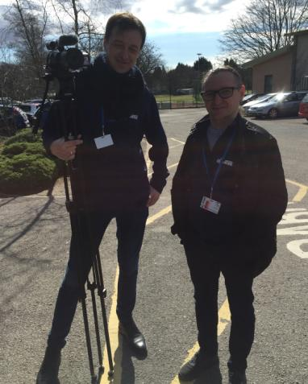

The French team:

Fanny and Marion helped by their teachers Marion and Cécile , had to write a report of the week where they discribe every day activities and the people that got involved.

Friday

On friday we have a day off. The Swedich and French went to Devonport High school for boys. They attended two lessons. It was interesting to see how english people work in class. After lunch we went to the Aquarium it was incedible, we loved it.

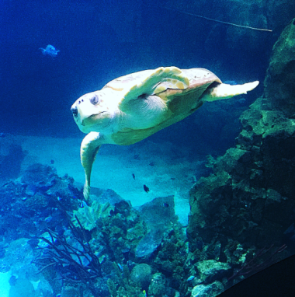

After that we all met at Pasta Bar to eat all together one last time. It was really good. Then went the time to say good bye, everybody went back to their hotel to have a good night before the trip on Saturday.

Thank you for this amazing week !!!!!!!!!!!

